PEERS
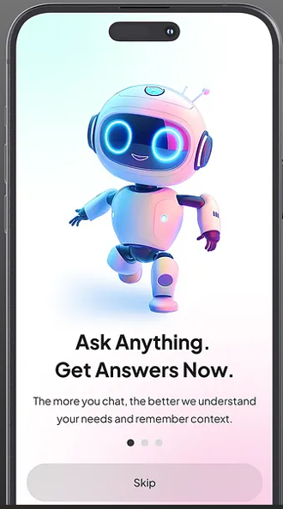
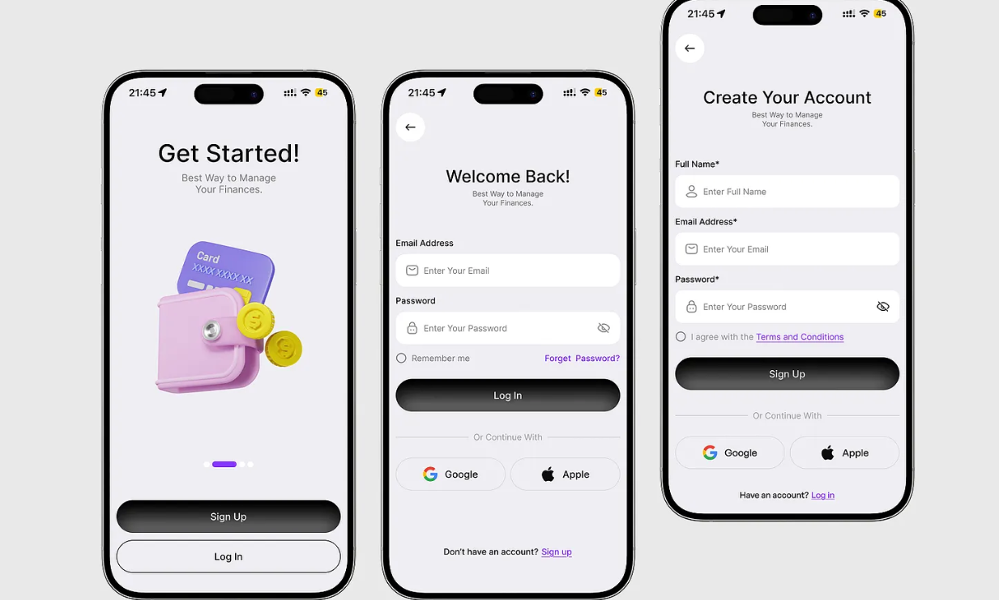
Discover People, Communities & Opportunities That Matter to You
The app is for both international as well as local students.
- Student Profiles — Create profiles containing university, course, country of origin, city, languages, interests, and year/intake to help students discover relevant peers.
- Student Community & Discussion Forum — Students can post questions, share experiences, provide advice, comment, upvote useful answers, and discuss topics related to studying and living abroad.
- University & City-Based Communities — Dedicated communities for specific universities and cities where students can exchange localized information about academics, accommodation, transportation, lifestyle, and campus life.
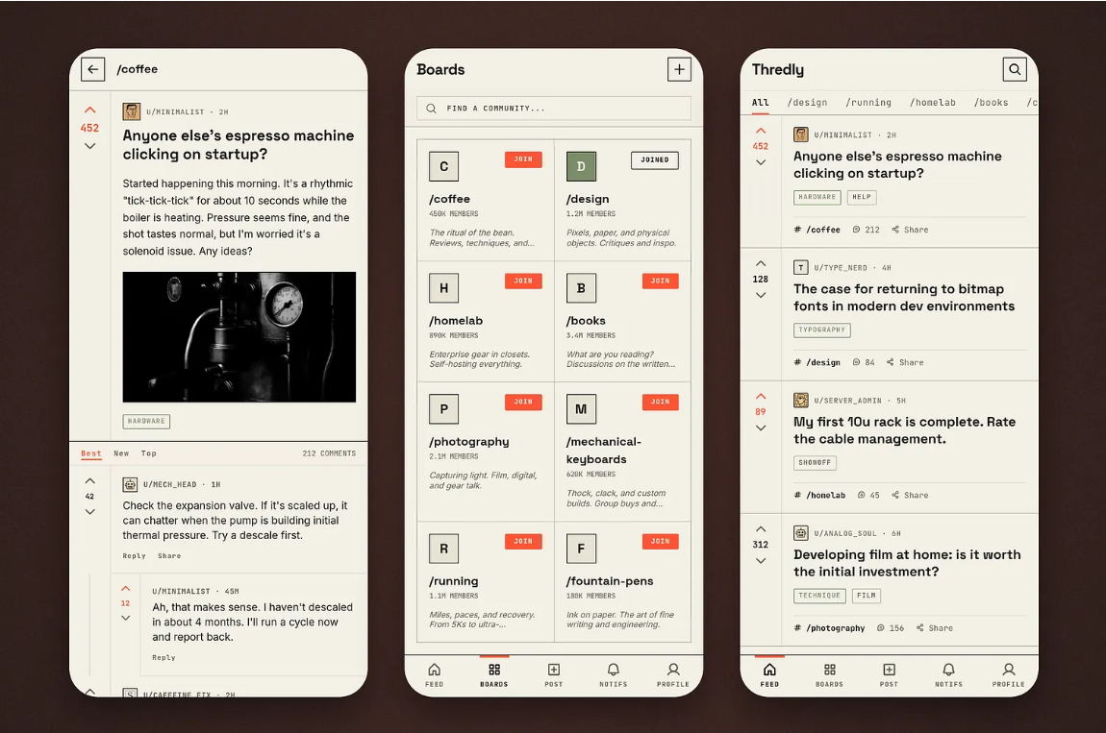
- Personalized Study-Abroad Checklist — Generate customized pre-departure and arrival checklists based on the student's destination, university, course, and intake, covering documents, accommodation, banking, transport, and other essentials.
- Accommodation & Local Services — Allow students to discover and share accommodation, roommates, nearby grocery stores, healthcare facilities, banks, transportation, restaurants, and other essential services.
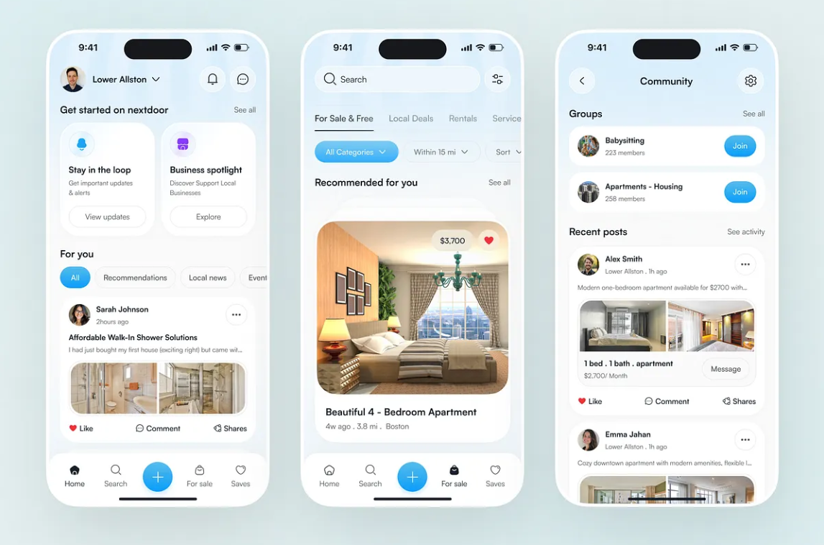
- Events & Meetups — Students, universities, and communities can create and discover events such as orientation sessions, cultural events, study groups, sports activities, networking events, and student meetups.
- AI-Powered Student Assistant — An AI assistant answers common questions about studying and living abroad, provides personalized guidance, summarizes information, and directs students toward relevant official resources.
- Language & Cultural Assistance — Provide t
- ranslation, commonly used local phrases, cultural tips, and practical guidance for communicating with landlords, university staff, employers, and local residents.
- Student Jobs, Internships & Scholarships — Provide a centralized section for discovering part-time jobs, internships, scholarships, campus opportunities, research positions, and other student-focused opportunities.
- Budget & Cost-of-Living Planner — Help students estimate monthly expenses such as rent, food, transportation, utilities, and entertainment, while allowing them to track and compare their actual spending.
- Help & Emergency Support — A structured "Need Help?" feature connects students with relevant community resources and provides quick access to official emergency contacts and essential services.
- Verified Information & Trust System — Verified university/student profiles, contributor reputation, ratings, and reliable-source references help distinguish trustworthy information from rumors or potentially misleading advice.
- Scam & Safety Reporting — Students can report suspicious accommodation listings, fraudulent job offers, scams, harassment, or misleading information, with moderation and community warnings.
- Personalized Recommendations & Notifications — Recommend relevant communities, people, events, accommodation, opportunities, discussions, and resources based on the student's university, location, interests, and activity.
Light and Dark Mode
- PEERS will support both Light Mode and Dark Mode.
- Light Mode: Uses a soft, slightly warm/off-white background instead of bright pure white to provide a comfortable, reading-friendly appearance.
- Dark Mode: Uses a soft, slightly grayish dark background instead of pure black to reduce harsh contrast and improve readability.
- Users can choose between Light, Dark, or System Default mode from Settings.
- All UI components will automatically adapt to the selected theme.

SIGNUP/LOGIN PAGE
a. Splash Screen
- Displays the PEERS logo when the application is launched.
- Automatically redirects the user to the Get Started/Onboarding screen after a short duration.
b. Get Started / Onboarding Screen
- Displays “Get Started” at the top of the screen.
- Contains a horizontally scrollable Lazy Row/Carousel displaying app features in a slideshow format.
- Each slide contains:
  - Relevant image/illustration.
  - Short description of the feature.
- Slides can be manually swiped and will also auto-scroll after a fixed interval.
- A page indicator such as 1/5, 2/5, 3/5... indicates the current slide.
- The onboarding will contain approximately 4–6 slides covering major features of PEERS.
- A fixed bottom section contains two buttons:
  - Log In
  - Sign Up
c. SignUp Page
- Displays fields for:
  - Full Name
  - Phone Number with a country-code dropdown (e.g., +91 – India, +1 – USA, etc.)
  - College/University with searchable college selection
  - College/University Unique ID
  - Gender using selectable options, with an option such as Prefer not to say
  - Password
- When the user selects the password field, the password requirements are displayed:
  - Minimum 8 characters
  - At least one special character
  - At least one numeric character
  - At least one uppercase alphabet
  - At least one lowercase alphabet
- A Sign Up button is provided after the required fields.
- Below the Sign Up button, a grey divider provides alternative registration options:
  - Continue with Google
  - Continue with Apple
- The final statement is:
  - “Already have an account? Log In”
- After submitting the registration form, the user proceeds to OTP verification before accessing the application.
d. Login Page
- Displays “Welcome Back” at the top.
- Provides fields for:
  - Email Address / Phone Number
  - Password
- A “Forgot Password?” option is displayed below the password field.
- A Login button is provided below the input fields.
- Below the Login button, a grey divider provides alternative login options:
  - Continue with Google
  - Continue with Apple
- The final statement is:
  - “Don’t have an account? Sign Up”
- If incorrect credentials are entered, an alert dialog is displayed:
  - “Incorrect login details. We couldn't verify your account. Please try again or reset your password.”
- The dialog provides:
  - Try Again – closes the dialog and clears the entered credentials.
  - Forgot Password – redirects the user to the password-reset process.
e. OTP Verification
- OTP verification is required after new user registration or after logging in as well.
- A 6-digit OTP is sent to the registered phone number through SMS.
- The OTP screen displays:
  - Registered phone number.
  - Six-digit OTP input fields.
  - Resend OTP option.
  - Countdown of 60 seconds before another OTP can be requested.
  - Total OTP validity period of 15 minutes.
- SMS OTP can be automatically detected/read where supported by the device (example sms).
- If the user does not receive the SMS, a 2nd option is provided to send the OTP through email.
- Email OTP must be entered manually by the user.
- If the OTP expires after 15 minutes, the user can request a new OTP.
- In the email otp page, user has the option to go back to SMS OTP format via phone number.
- After successful OTP verification, the user is redirected to the Student Profile Setup/Dashboard.

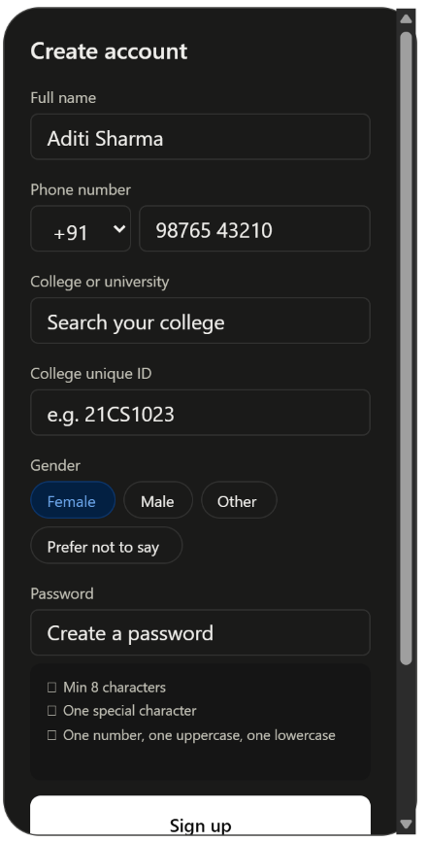
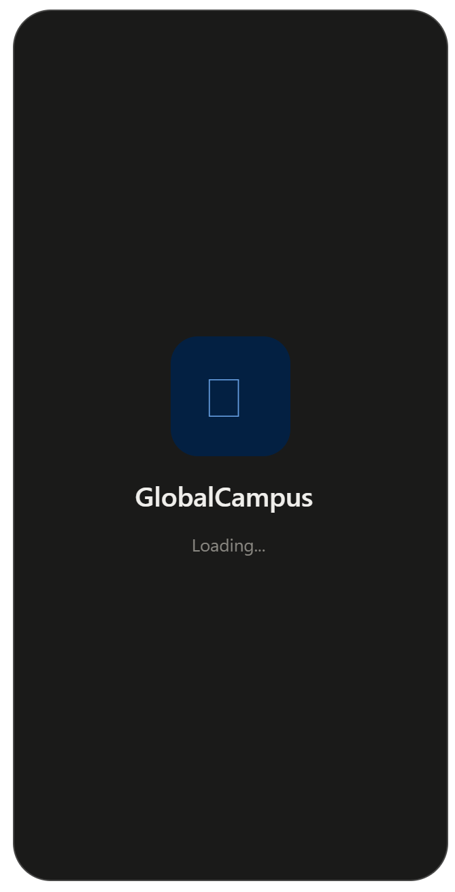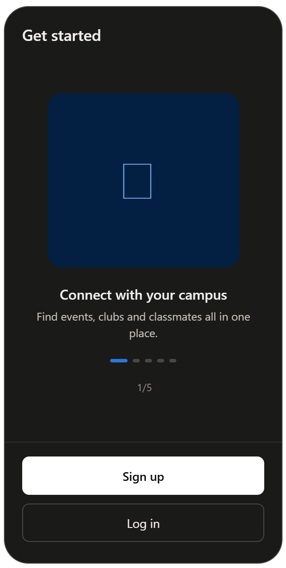
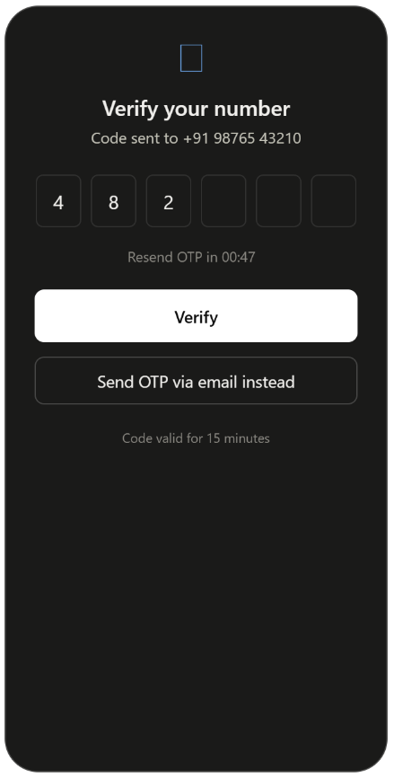
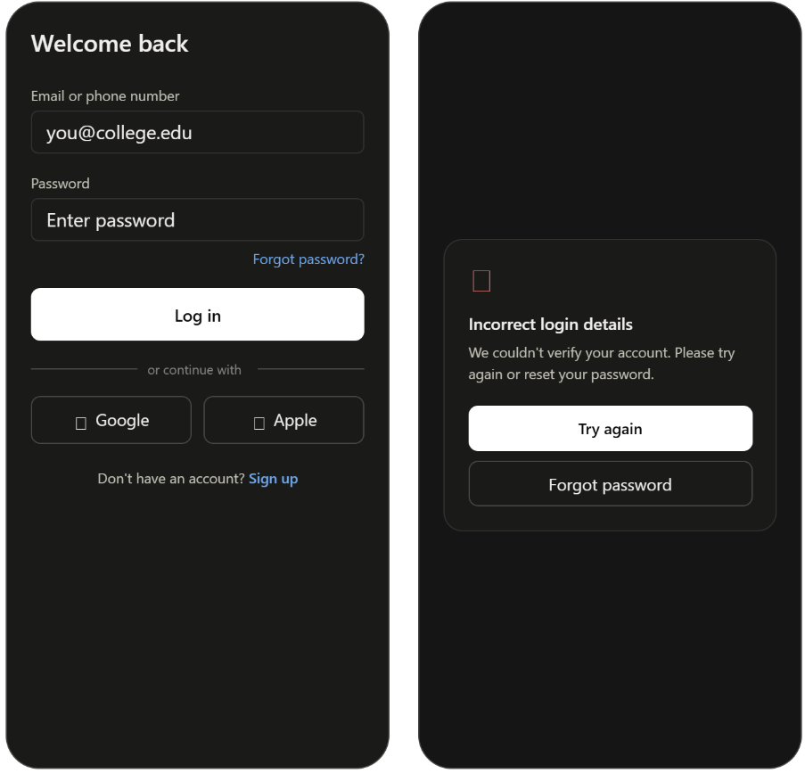

PROFILE SETUP PAGE (AFTER NEW SIGN IN)
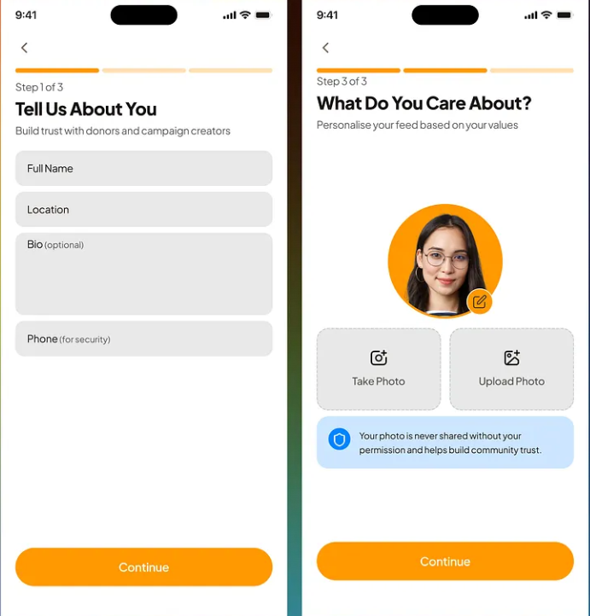

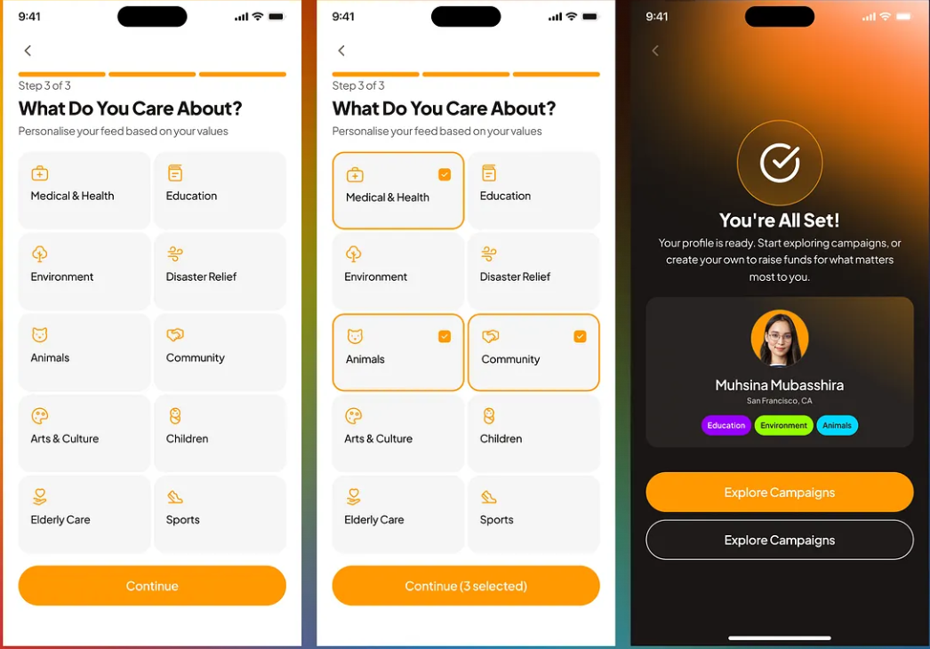

1st Slider - Form input:- (Tell us about yourself)
Input | Type | Required?
Country of Origin | Country dropdown/search | Yes
Current Country | Country dropdown/search | Yes
Current City | Search/dropdown | Yes
University/College | Search/select | Already collected during Sign Up
Course/Program | Search/select | Yes
Degree Level | Dropdown/cards — Undergraduate, Postgraduate, Diploma, PhD, Exchange Program, Other | Yes
Year of Study | Dropdown | Yes
Expected Graduation Year | Dropdown | Optional
Bio / About Me | Multiline text | Optional
Languages Known | Multi-select | Optional

- Course/Program: Prefer search/select over free text. This keeps data consistent.
- Languages Known: I'd make this optional, because students can add/edit it later.
- Expected Graduation Year: Optional is fine.
- Your "Degree Level" has a typo: Undergraduate, not "Undergraduated."
Button
[ Continue ] rather than "Save".

2nd Slider – Profile Picture Input
Profile picture options
The user can:
- Take Photo using the device camera
- Upload/Browse from gallery
- Choose an Avatar from predefined PEERS avatars
Privacy statement
Your idea of displaying a privacy message is good, but I'd phrase the requirement carefully:
Your personal photos are not shared with third-party applications without your permission.
I wouldn't promise that the image is never shared with third parties unless your actual backend/privacy architecture guarantees that. For example, your cloud storage provider may technically process the image.
Image editor
After selecting/taking a picture:
- Display the image inside a circular crop frame.
- User can:
  - Zoom in
  - Zoom out
  - Move image horizontally
  - Move image vertically
- Do not automatically crop/position the image.
- User manually adjusts the image until satisfied.
Buttons:
[ Cancel ] [ Save ]
- Cancel: Discard changes and return to the profile-picture selection screen.
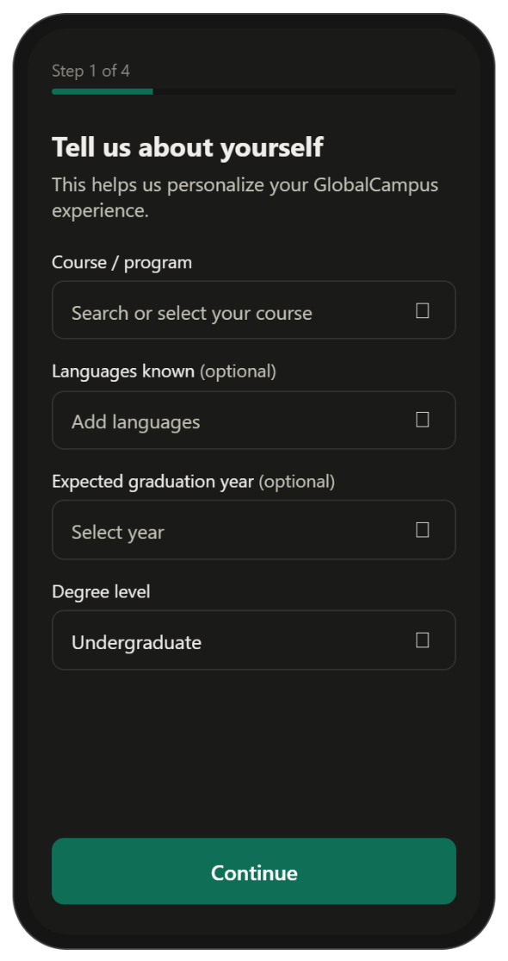
- Save: Save the adjusted profile picture and return to Step 2.
Final navigation
[ Back ] [ Continue ]
→ Continue to 3rd Slider – Interests
This distinction is important: Save applies to the photo editor, while Continue moves between onboarding steps.

3rd Slider – Card Inputs: “What Are You Interested In?”
This is good. I'd divide the cards into logical categories so you don't end up with a giant random grid.

📚 Learning & Career
- Academics & Study
- Technology
- Career & Jobs
- Entrepreneurship
- Freelancing
- Content Writing
- Content Creation
🎨 Creative
- Music
- Arts & Creativity
- Photography
- Filmography
- Dance
- Vlogging
🏃 Lifestyle & Sports
- Sports
- Gym & Fitness
- Martial Arts
- Travel
- Food & Cooking
🎮 Entertainment
- Gaming
- Books
- Movies & Entertainment
🌍 Social & Community
- Culture & Languages
- Volunteering
- Social Events
You can still display them as one multi-select card grid; the categories are mainly for organization.
Selection behavior
- Multiple cards can be selected.
- Selected cards receive a highlighted border/checkmark.
- Unselected cards remain neutral.
- Ideally require at least 3 interests.
Button:
[ Back ] [ Continue ]
→ 4th Slider.
I'd use "Continue (3 selected)" dynamically, like your reference UI.

4th Slider – Card Inputs: “What Do You Need From PEERS?”
This is one of the most important screens, because these selections can directly determine the user's personalized dashboard.
Cards
- 🏠 Accommodation
- 👥 Make Friends
- 🎓 University Help
- 💼 Jobs & Internships
- 📄 Visa & Documents
- 💰 Budget & Finance
- 🚇 Transportation
- 🏥 Healthcare
- 🛒 Daily Life
- 🎉 Events & Activities
- 🗣️ Language & Culture
- 🤝 Community Support
Again:
- Multi-select
- Highlight selected cards
- Require at least 2–3 selections
- Allow users to change these later from their profile/settings.
Button
Instead of:
Save / Back
I'd use:
[ Back ] [ Complete Profile ]
Because this is the final onboarding step.
Put a progress indicator at the top of every step:
Step 1 of 4
━━━━━━━━━━━━
Step 2 of 4
━━━━━━━━━━━━
etc.
And allow:
← Back
but don't allow users to skip the entire profile setup if the information is needed for personalization. They can leave optional fields blank.
One architectural point
Don't think of these four screens as four separate "profile pages." They're better documented as a single Profile Onboarding flow with four steps.
That distinction will help later when you implement it:
Profile Onboarding
- Step 1 → Basic Information
- Step 2 → Profile Picture
- Step 3 → Interests
- Step 4 → PEERS Preferences
Then, after completion, the user never sees this flow again unless they explicitly choose "Edit Profile."
That is a clean setup for PEERS.

Dashboard Page
Header Requirements
- Top-left section:- Hamburger menu icon will be displayed in the top-left corner. Tapping the hamburger icon will open the Side Navigation Menu.
- Welcome Section - A personalized welcome message will be displayed beside/below the hamburger icon (“Good Morning/Afternoon/Evening, Robin” ) (as per the time), The user's name will be dynamically displayed. The user's short college/university name will be displayed below the welcome message (Example: “Lovely Professional University” ).The welcome message will be left-aligned.
- Top-right section - A Notification/Bell icon will be displayed in the top-right corner. A red notification dot will appear whenever the user has one or more unread notifications. Tapping the notification icon will open the Notifications screen.
Side Navigation Menu - Tapping the hamburger icon opens a side navigation drawer. The top portion of the drawer will contain:- User's circular profile picture, A small green online-status dot over the profile picture when the user is online, User's name.
- The following options will be available in the side menu:
- Profile - Edit Profile
- Community – Discussion, Invite a Friend
- Help & Support - Quick Help, Chatbot
- Application – Settings, About PEERS
- The bottom portion of the side menu will contain: -“❤️ Love the app? Rate us” hyperlink/button, Sign Out / Logout option.
- Selecting Sign Out/Logout will display a confirmation dialog before logging the user out.
Header Appearance
- The header will not have a strong rectangular background.
- It will appear to float naturally over the white background.
- No visible horizontal divider will separate the header from the rest of the Dashboard.
- No unnecessary borders will be used around the header.
- The overall header should maintain a clean, minimal, and lightweight appearance.

Other Necessary Requirements of Side Menu Options
- Edit Profile - The Edit Profile option will navigate to a separate Edit Profile page. The user will be able to view and modify their previously entered profile information. Changes will be saved only after the user selects the appropriate Save/Update option.
- Discussion & Invite a Friend - Discussion will navigate to the Discussion/Forum page. The same Discussion/Forum page will also be accessible through the Discussion option in the bottom navigation bar. Invite a Friend will automatically close the side navigation menu and open an Invite/Share bottom sheet over the Dashboard. The bottom sheet will provide sharing options similar to the sharing interface used by social media applications. Available options may include: WhatsApp Instagram Snapchat Other supported messaging/social applications Copy Link. The user will be able to share the PEERS application link with contacts who are not currently registered on the application. Selecting Copy Link will copy the PEERS invitation/download link to the device clipboard. After selecting a supported application, the system's native sharing mechanism will be used to share the invitation link.
- Rate the App - The “Love the app? Rate us” hyperlink will redirect the user to the PEERS Google Play Store listing. The user can provide a rating and review through the Google Play Store. The option should open the Play Store directly when it is available on the user's device.
- Side Menu Overlay Behavior - The side navigation menu will open as an overlay above the Dashboard/current screen. The underlying screen will not resize or recompose its layout based on the width of the side menu. A semi-transparent grey/dim overlay will appear over the underlying screen whenever the side menu is open. The dimmed area will indicate that the underlying screen is temporarily inactive. User interaction with the underlying screen will be disabled while the side menu is open. Tapping the dimmed area or using the appropriate back action will close the side menu. The side menu will slide in/out with a smooth animation.
- Common Header Component - The Header will be a common UI component used throughout the application. It will contain the common elements: Hamburger menu, Welcome/user information where applicable, Notification icon. The Header will be implemented as a separate reusable Compose component/file. Individual screens will call/reuse this common Header component rather than implementing the header separately on every screen. Navigation and header actions will be handled through the application's navigation/state structure so that the same component can be reused across screens.

Main Dashboard Screen
- Header will be displayed at the top of the Dashboard and will contain the common Hamburger Menu, Notification Icon, and personalized greeting. The greeting will dynamically change according to the current time, displaying “Good Morning, Robin”, “Good Afternoon, Robin”, or “Good Evening, Robin”.
- University/College Name will be displayed below the personalized greeting in a smaller text format, showing the student's associated college or university, such as “Lovely Professional University”.
- Date Calendar Slider will be displayed below the Header and will contain a horizontally scrollable list of days and dates. The current/selected date will be visually highlighted, and dates having scheduled events will contain a small event indicator.
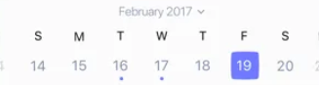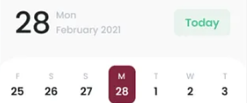
- Date Selection will dynamically update the content displayed below the calendar so that the events shown correspond to the selected date.
- Top Events section will contain a horizontally scrollable Lazy Row displaying event cards corresponding to the selected date. The title “Top Events” will be displayed at the beginning of the section, and a “View All Events” button will be displayed on the same row as the title, which will navigate the user to the dedicated Events Page.
- Event Cards will display relevant information such as Event Image, Event Name, Date/Time, Location, and a “View Details” button, which will navigate the user to the respective Event Details Page.
- When no events are available for the selected date, a dedicated card containing “View Upcoming Events →” will be displayed instead of the event cards. Selecting this card will navigate the user to the Events Page, where upcoming events can be explored.
- The Dashboard will continue below the Top Events section with additional personalized sections and features, which will be defined separately as the Dashboard design is developed further.

People You May Know & Discover Section
Aarav Sharma
Computer Science • LPU
5 mutual connections · 3 common interests

Profile Pic

Connect
View Profile

- People You May Know section will be displayed directly below the Top Events section on the PEERS dashboard.
- The section title will be “People You May Know”.
- The same title row will contain “View Similar Profiles →” at the end.
- “View Similar Profiles →” will navigate the user to a dedicated page containing more recommended student profiles.
- The section will display recommended students who are not directly connected to the current user.
- Recommended users can be 2nd-degree or 3rd-degree connections based on the PEERS connection network.
- A 1st-degree connection will represent a user directly connected to the current user.
- A 2nd-degree connection will represent a person connected to one of the current user's connections.
- A 3rd-degree connection will represent a person connected through a 2nd-degree connection.
- Recommendations can also include students who have similar profiles even when they are not 2nd- or 3rd-degree connections.
- Recommendation factors will include mutual connections, university, course, year, city, interests, and needs.
- The recommendation system will initially use a rule-based weighted scoring algorithm rather than machine learning.
- Same university will contribute +30 points to the recommendation score.
- Same course will contribute +20 points to the recommendation score.
- Same year of study will contribute +10 points to the recommendation score.
- Same city will contribute +10 points to the recommendation score.
- Each common interest will contribute +5 points to the recommendation score.
- Common needs will contribute +5 points to the recommendation score.
- Each mutual connection will contribute +15 points to the recommendation score.
- The recommendation score will be calculated for eligible student profiles.
- Profiles will be ranked from the highest recommendation score to the lowest.
- PEERS can display the top 5 recommended profiles in the dashboard section.
- The current user will never be recommended to themselves.
- Users who are already directly connected to the current user will not be shown in this section.
- Profiles with an already pending connection request should not receive another duplicate request.
- A future option can be added to hide or dismiss a recommended profile.
- The recommendation card will be displayed in a horizontal LazyRow.
- Each profile will be displayed in a compact card format.
- The profile card will contain the person's name.
- The profile card will contain the person's profile picture.
- The profile card will display the person's course and university.
- The profile card will display the number of mutual connections.
- The profile card will display the number of common interests.
- The profile card will contain button: “View Profile”.
- The reason for using only “View Profile” on the card is that PEERS will not provide social-media features such as posts, stories, feeds, or other profile content like Instagram or Facebook.
- A complete standalone profile page is therefore unnecessary for the People You May Know feature.
- Clicking “View Profile” will open a modal bottom sheet instead of navigating to a separate profile page.
- The modal bottom sheet will appear over the current dashboard screen.
- The bottom sheet will contain the person's profile picture.
- The bottom sheet will contain the person's name.
- The bottom sheet will contain their course/program.
- The bottom sheet will contain their university/college.
- The bottom sheet can display their year of study.
- The bottom sheet can display their city.
- The bottom sheet will display relevant mutual connections.
- The bottom sheet will display relevant common interests.
- The bottom sheet will contain a “Connect” button.
- The bottom sheet can show the reason for recommendation, such as “5 mutual connections” or “3 common interests”.
- The user can close the bottom sheet and return to the dashboard without leaving the current screen.
- Clicking “Connect” will create a connection request between the two users.
- The connection request will contain the sender ID, receiver ID, request status, and creation time.
- The initial request status will be Pending.
- Once a request is sent, the sender's button will change from “Connect” to “Request Sent”.
- The sender should not be able to send another request while the existing request is pending.
- The recipient will receive an in-app notification about the connection request.
- The notification will be accessible through the notification icon in the common header.
- The notification icon will display a red indicator/dot when unread notifications are present.
- The recipient can open the notification and see that another student has requested to connect.
- The recipient will have “Accept” and “Decline” options for a pending connection request.
- Selecting “Accept” will change the request status to Accepted.
- Selecting “Accept” will establish a connection between the two users.
- Selecting “Decline” will change the request status to Declined.
- After accepting or declining a request, the recipient will no longer see the request as pending.
- The original sender will receive an in-app notification when their request has been accepted.
- The original sender will also receive an in-app notification when their request has been declined.
- After acceptance, the sender's profile card/button state will change to “Connected”.
- After a declined request, the sender can potentially see “Connect” again and send another request according to the application's request policy.
- Notifications will contain information such as the person involved, notification type, message, read/unread status, and creation time.
- The notification system can initially be implemented entirely as in-app notifications using Firebase/Firestore.
- Firebase Cloud Messaging can be added later if PEERS needs real phone push notifications when the app is closed.
- The user does not need to create a social-media-style profile with posts, stories, followers, or a personal feed for this feature.
- The Profile Preview Bottom Sheet keeps the feature simpler while still giving users enough information to decide whether they want to connect.
- The People You May Know feature is considered moderate difficulty to implement.
- The profile card UI can be implemented using Jetpack Compose LazyRow.
- The profile preview can be implemented using a Compose Modal Bottom Sheet.
- The recommendation logic can be implemented using simple weighted scoring without requiring an ML model.
- Firebase/Firestore can be used to store student profiles, connection requests, and notifications.
- The main implementation complexity will come from managing connection-request states, preventing duplicate requests, updating connections, and generating notifications.
- The complete feature is considered feasible for a college project.
Discover What Interests You
- Below the People You May Know section, the dashboard will contain a section titled “Discover What Interests You”.
- This section will provide quick access to the different features available within PEERS.
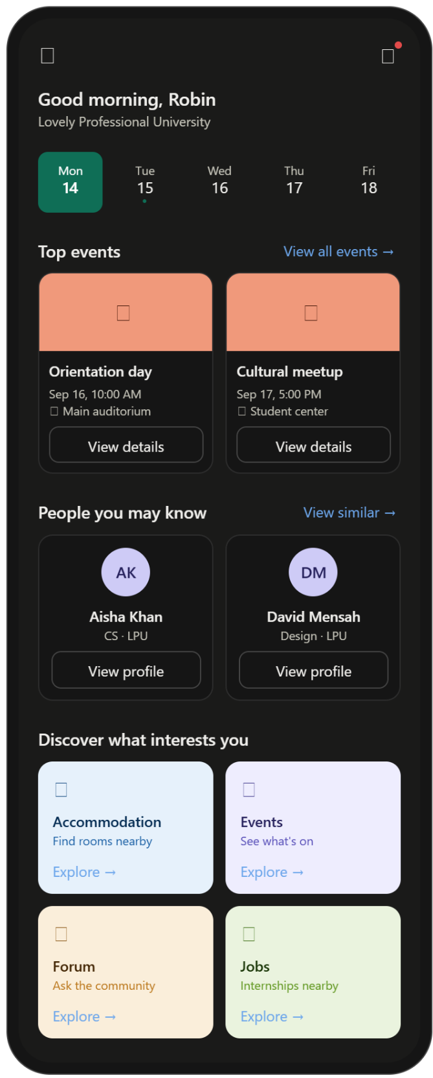
- The section will use a 2-column grid layout.
- Each feature will be represented using an individual card.
- The cards will be selected according to the features finalized for PEERS.
- Possible cards will include Nearby Accommodation, Events, Forum, Jobs & Internships, Scholarships, Communities, and other relevant PEERS features.
- Each card will contain a relevant background image representing the feature.
- A semi-transparent overlay will be placed over the background image to improve text readability.
- The cards can use a subtle glassmorphism-style appearance using translucency, blur, and a subtle border/shadow where appropriate.
- Each card will contain the feature name.
- Each card can contain a short description or supporting text.
- Each card will contain a button or action such as “Explore →” or “View”.
- Clicking the button will navigate the user to the corresponding feature page.
- The Nearby Accommodation card will use an accommodation-related image as its background.
- The Events card will navigate to the dedicated Events page.
- The Forum card will navigate to the Discussion/Forum section.
- Additional cards will be added as the remaining PEERS features are finalized.
- The cards should remain visually compact because this section is part of the dashboard rather than a full feature page.
- The overall dashboard flow at this point will be Header → Date Calendar Slider → Top Events → People You May Know → Discover What Interests You.
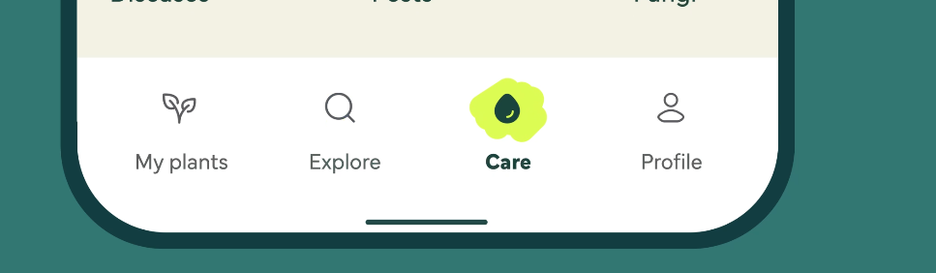

Bottom Navigation Bar
Icon | Label | Purpose
🏠 | Home | Main personalized PEERS dashboard
👥 | Community | Discussions, forums and student communities
📅 | Events | Browse and manage events
👤 | Profile | User profile, interests, needs and profile settings

The icons will be outlined, and when we click on the it, it becomes filled with a circle background or however it is depicted in the above image (marker, highlighter animation). The bottom navigation should remain fixed across the main screens. The currently active destination should have a clear selected-state indication.

NEARBY ACCOMODATION
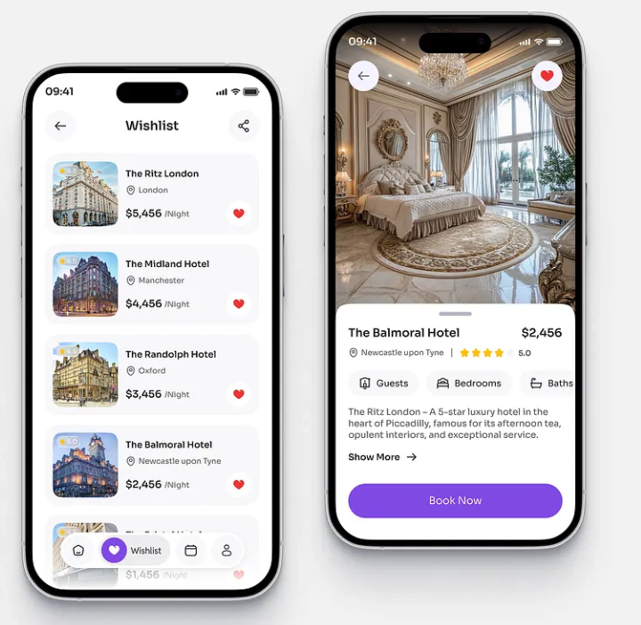
• Nearby Listings – Show PGs, hostels, shared apartments, flats and student residences near the user's university/current location.
• Search & Filters – Filter by distance, rent range, accommodation type, gender preference, furnished/unfurnished, amenities, etc.
• Accommodation Details – Photos, rent, deposit, location, distance from university, available amenities and basic rules.
• Map View – Show accommodation locations on a map.
• Roommate Options – Allow students to find potential roommates based on preferences and compatibility.
• Save/Favorite – Save interesting accommodations for later.
• Contact/Enquiry – Contact the owner/manager or send an enquiry; PEERS doesn't process the booking itself.
• Student Reviews & Ratings – Students can share experiences and rate accommodations.
• Verified Listings – Identify listings that have been verified by PEERS or a trusted source.
• Report Listing – Report scams, misleading information or suspicious listings.
• Nearby Essentials – Optionally show nearby grocery stores, healthcare, transportation, banks, etc.
• Personalized Recommendations – Recommend accommodations based on university, location, budget and user preferences.

🏠 Nearby Accommodation
- The Nearby Accommodation feature will allow students to discover student-friendly accommodation such as PGs, hostels, shared apartments, flats, and student residences near their university or current location.
- The Accommodation Listings page will display available accommodation in a scrollable card/list layout.
- Each accommodation card will contain only minimal, essential information:
  - Accommodation image
  - Accommodation name
  - Accommodation type
  - Distance from university
  - Wishlist icon
  - View Details button
- The Wishlist icon will allow students to save or remove an accommodation directly from the listing card.
- Tapping View Details will open the corresponding Accommodation Details screen.
- A “+” icon will be displayed on the Accommodation Listings page to allow students to contribute accommodation listings they know about.
- Clicking the “+” icon will open the Add Accommodation form.
- The Add Accommodation form will allow students to provide:
  - Accommodation name
  - Accommodation type
  - Address/location
  - Rent
  - Deposit
  - Amenities
  - Availability
  - Rules
  - Contact information
  - Description/other relevant information
  - Images
- Students will be able to upload multiple accommodation images.
- For the accommodation location, students will be able to either:
  - Search/enter the location manually, or
  - Select the location directly using Google Maps
- When a location is selected through the map, PEERS will store the accommodation's latitude, longitude, and formatted address.
- The stored coordinates will be used for:
  - Displaying the accommodation on the PEERS map
  - Calculating its distance from the university
  - Opening the accommodation's location in Google Maps
- The Add Accommodation form will contain Save and Cancel buttons.
- Selecting Save will submit the accommodation listing to PEERS.
- The student who submits the accommodation will be recorded as the contributor of that listing.
- The submitted accommodation information will be stored in the Firebase Firestore database.
- The listing will initially have a pending status while it goes through the required review/activation process.
- After successful submission, a Snackbar will be displayed to confirm the contribution.
Your listing will be available in PEERS within 24 hours or earlier. Thank you for your contribution!
- The listing will be activated in the database once the required review/activation process is completed.
- Once activated, the accommodation will have an active status and will automatically become available in the Accommodation Listings page.
- The accommodation information will be retrieved dynamically from Firestore, so adding a new accommodation will not require an application update.
- A reusable Accommodation Details screen will be used for all accommodation listings, with its content dynamically populated using the selected accommodation's database information.
Community Verification
- The accommodation feature will support a community-based verification system where students can confirm that a listing is genuine.
- Each accommodation will have a “Mark as Genuine” / “Verify Listing” option.
- Students can verify an accommodation if they know about or have genuine experience with it.
- Each student can verify a particular accommodation only once.
- PEERS will maintain the number of students who have verified each accommodation.
- Once the predefined verification threshold is reached, the accommodation will receive a “Community Verified” badge.
- The listing can display information such as:
  - 🟢 Community Verified
  - Verified by 12 students
- Students can remove their verification if they later discover that the listing information is no longer genuine.
- The verification count and status will be updated accordingly.
- A Report Listing option will allow students to report suspicious, misleading, fraudulent, inappropriate, or otherwise problematic accommodation listings.
- Community verification will indicate that multiple PEERS students have confirmed the listing; it will not constitute a guarantee of the accommodation's safety or quality.
Search and Filters
- Accommodation listings will support search and filtering based on relevant criteria.
- Filters can include:
  - Rent range
  - Distance from university
  - Accommodation type
  - Gender preference
  - Furnished/Unfurnished
  - Amenities
  - Availability
  - Other relevant preferences
Accommodation Details Screen
- Selecting an accommodation will open a dedicated Accommodation Details screen.
- The top section will contain:
  - Back button
  - Accommodation image carousel
  - Location icon
  - Wishlist icon
  - Share icon
- Accommodation images will be displayed in a horizontally swipeable image carousel.
- Left/right slide controls can be provided to allow students to navigate through the available images.
- The Location icon will open the accommodation's location in Google Maps.
- The Wishlist icon will allow the student to save or remove the accommodation from their wishlist.
- The wishlist state will remain synchronized with the wishlist icon shown on the accommodation listing card.
Accommodation Information
- The Accommodation Details screen will use a persistent bottom sheet that remains fully expanded to display the accommodation information.
- The bottom sheet will contain:
  - Accommodation name
  - Location/address
  - Rent
  - Deposit
  - Distance from university
  - Accommodation type
  - Amenities
  - Availability
  - Rules
  - Rating/reviews
  - Community verification status
  - Contact/Enquiry option
  - Roommate-related actions
  - Report Listing option
Contact / Enquiry
- The Accommodation Details screen will provide a Contact/Enquiry option.
- Students can use this option to contact the accommodation owner/manager or submit an enquiry.
- PEERS will not provide hotel-style booking or reservation functionality.
- The feature is intended for accommodation discovery and student housing assistance, rather than booking or payment processing.
Share Accommodation
- The Accommodation Details screen will provide a Share icon.
- Tapping the Share icon will open the device's native sharing sheet.
- Students can share the accommodation through applications such as:
  - WhatsApp
  - Instagram
  - Snapchat
  - Messages
  - Email
  - Other installed messaging/sharing applications
- PEERS will generate a predefined sharing message containing the accommodation name.
Example:
Check out this accommodation – [Name of Accommodation] on PEERS.
- The shared content will contain a link to the specific accommodation.
- If the recipient already has PEERS installed, opening the link will take them directly to that accommodation's Details screen.
- If the recipient does not have PEERS installed, the link will redirect them to the Play Store to download PEERS.
- After installation, the deep-linking flow can take the user to the specific accommodation that was originally shared.
Reviews
- Each accommodation will have a Reviews button displaying its overall rating and number of reviews, for example:
  - ⭐ 4.3 (28 Reviews)
- Clicking Reviews will open a Reviews Dialog for that particular accommodation.
- The Reviews Dialog will display student reviews containing:
  - Reviewer name
  - Rating
  - Date
  - Written review
- The Reviews Dialog will contain an Add Review button.
- Students who have stayed at or have genuine experience with an accommodation will be eligible to submit a review.
- The Add Review form will allow students to provide:
  - 1–5 star rating
  - Optional review title
  - Written review
- A student can submit one review per accommodation.
- Students will be able to report reviews that are fake, abusive, inappropriate, or misleading.
Roommate Feature
- The Accommodation Details persistent bottom sheet will contain two roommate-related actions:
  - Find a Roommate
  - Looking for a Roommate
Looking for a Roommate
- Looking for a Roommate will allow a student to indicate that they are interested in the selected accommodation and are looking for someone to share it with.
- Clicking Looking for a Roommate will open a custom Roommate Information & Sharing Dialog.
- The dialog will allow the student to choose which personal information they want to share with potential roommates.
- Available sharing options can include:
  - Name
  - Phone number
  - Gmail/Email
  - Instagram
  - Snapchat
  - Other permitted contact details
- The student will also be able to enter a custom message for potential roommates.
- The message can contain preferences or conditions such as:
  - No smoking
  - Food preferences
  - Lifestyle preferences
  - Study habits
  - Other roommate requirements
- The dialog will contain Save and Cancel buttons.
- Selecting Save will associate the student with the selected accommodation as Looking for a Roommate.
- PEERS will store:
  - Student ID
  - Accommodation ID
  - Roommate-seeking status
  - Selected contact-sharing permissions
  - Custom message
- After saving, the button will change to:
  - ✓ You're looking for a roommate
- Selecting Cancel will close the dialog without enabling the roommate status.
- Clicking ✓ You're looking for a roommate again will display a confirmation dialog:
Are you sure you want to remove yourself from roommate requests?
- The confirmation dialog will contain Proceed and Cancel buttons.
- Selecting Proceed will remove the student from the roommate-seeking list for that accommodation.
- Selecting Cancel will retain the student's roommate-seeking status.
Find a Roommate
- Find a Roommate will display students who have also marked the same accommodation as “Looking for a Roommate.”
- The feature will open a dialog/bottom sheet containing eligible students interested in that accommodation.
- Each potential roommate can display:
  - Profile picture
  - Name
  - University/course
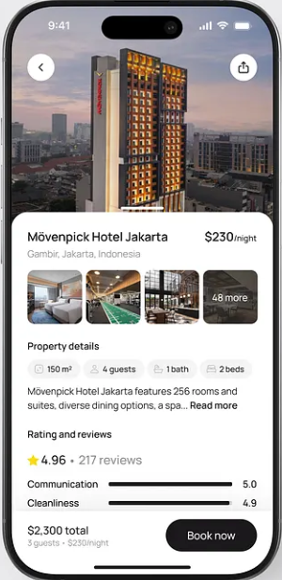
  - Common interests
  - Other shared information permitted by the student
- Each potential roommate will have a Roommate Request button.
- Selecting Roommate Request will send a predefined roommate request notification.
Notification:
[User Name] has requested you to join as a roommate for [Accommodation Name].
- The recipient will receive the request through the Notifications section, accessible from the notification icon in the common header.
- The recipient will be able to Accept or Decline the request.
- The roommate request will maintain a status such as:
  - Pending
  - Accepted
  - Declined
- Contact information will not be exposed before the request is accepted.
After Roommate Request Acceptance
- Once the recipient accepts the roommate request, a dialog will appear with the heading:
Here are ways you can connect
- The connection dialog will display only the contact information that the other student explicitly selected to share.
- Shared information can include:
  - Phone number
  - Gmail/Email
  - Instagram
  - Snapchat
  - Other permitted contact details
- The student's custom roommate message will also be displayed.
- The purpose of the dialog is to allow both students to communicate directly and discuss:
  - Accommodation arrangements
  - Roommate preferences
  - Living conditions
  - Other relevant requirements
Overall Scope
- The Nearby Accommodation feature will support:
  - Accommodation discovery
  - Search and filtering
  - Map-based discovery
  - Community verification
  - Reviews and ratings
  - Wishlist/saving
  - Location and Google Maps integration
  - Accommodation sharing
  - Contact /enquiry
  - Roommate interest
  - Roommate discovery
  - Roommate requests
  - Notifications
  - Student-to-student connection after acceptance
  - Listing and review reporting
  - Community contributions
  - • PEERS will not handle accommodation booking, reservations, or payments. There will not be bottom navigation bar in the accomodation details page.

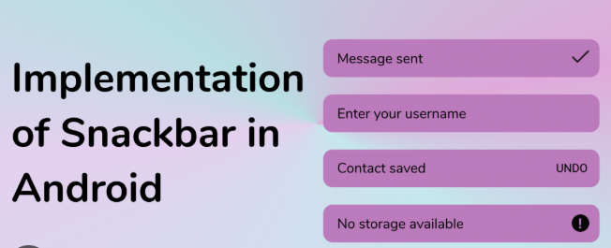




Slide arrows to swipe through
Share the accomodation on various messaging apps like whatsapp insta snapchat (same as refer to a friend feature), with a defined message:-
“Check out this accomodation – {Name of accomodation} on PEERS
[Generate a link which will take the user to app -> accomodation page -> to this particular accomodation);
Don’t have the app? Link to download:- [Playstore Link]”
Wishlist to save the accomodation for future
Shows location by redirecting on google maps
All the necessary details
Required and discussed

Image carousel

The idea for my app logo is the following details:-
    - It will form a generic ‘P’ alphabet
    - The structure of the p will consist of dots which (big circles 6-8) forming the alphabet P
    - Inside each circle there will be cliparts which will give sense of a windows of the apartment, like when we look at an apartment complex will see so many windows and different people living their lives, someone is studying, someone is watching tv, someone is spending time with family etc., so here also every circle will represent some form of ethinicity like african man, muslim women, indian – (northeast girl, north boy, south indian girl) etc. and all the images of the people will be in white color (or any other color which you can suggest) because the color of the dots will follow these palette because I will use the same palette for the app as well to maintain uniformity, so basically these colors are the identity of my app starting from logo to the last screen and button of the app.
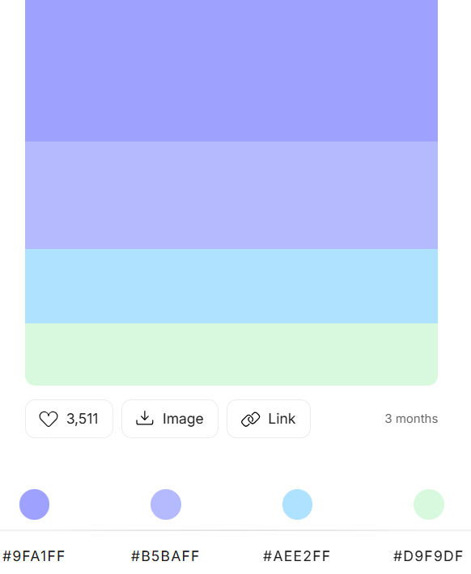

Color scheme of the app
Light theme:-
val LightBackground = Color(0xFFFAF8F4)
val LightSurface = Color(0xFFFFFFFF)
val LightSurfaceVariant = Color(0xFFF1EFEA)
val LightOnBackground = Color(0xFF1F1F24)
val LightOutline = Color(0xFFD5D2CB)

Dark Theme:-
val DarkBackground = Color(0xFF1E1F24)
val DarkSurface = Color(0xFF282A30)
val DarkSurfaceVariant = Color(0xFF32343B)
val DarkOnBackground = Color(0xFFE8E8EC)
val DarkOutline = Color(0xFF4A4C55)

Brand Palette:-
val PeersIndigo = Color(0xFF9FA1FF) // primary
val PeersLavender = Color(0xFFB5BAFF) // primary container / highlights
val PeersSky = Color(0xFFAEE2FF) // secondary
val PeersMint = Color(0xFFD9F9DF)

Text color:- val PeersInk = Color(0xFF1B1C3A)

APP STRUCTURE
com.example.peers
│
├── MainActivity.kt
│
├── navigation/
│ └── AppNavigation.kt
│
├── ui/
│ ├── theme/
│ │ ├── Color.kt
│ │ ├── Theme.kt
│ │ └── Type.kt
│ │
│ └── components/
│ └── ...
│
├── features/
│ │
│ ├── auth/
│ │ └── ...
│ │
│ ├── profile/
│ │ ├── ProfileSetupScreen.kt
│ │ ├── ProfileSetupViewModel.kt
│ │ ├── ProfileSetupState.kt
│ │ │
│ │ └── components/
│ │ ├── ProfileProgressBar.kt
│ │ ├── BasicInformationStep.kt
│ │ ├── ProfilePictureStep.kt
│ │ ├── InterestsStep.kt
│ │ └── NeedsStep.kt
│ │
│ └── dashboard/
│ └── ...
│
└── data/
└── ...

